ПРИЛОЖЕНИЕ

к чертежу межевания территории для строительства объекта «Газопровод межпоселковый до с. Козиха – д. Березовка Ордынского района Новосибирской области» в границах Березовского и Козихинского сельсоветов Ордынского района Новосибирской области

Таблица № 1

Перечень земельных участков (частей земельных участков), предполагаемых к изъятию для государственных нужд

| № п/п | Кадастровый номер земельного участка | Площадь  всего, кв. м | Площадь  изъятия, кв. м |
| --- | --- | --- | --- |
| 1 | 2 | 3 | 4 |
| 1 | 54:20:000000:381 | 11449 | 8 |
| 2 | 54:20:030201:213 | 198231 | 13 |
| 3 | 54:20:031216:7 | 3687 | 372 |
| 4 | 54:20:030201:290 | 9087 | 33 |
|  | Итого: |  | 426 |

Схема № 1

Разбивочный план поворотных точек границ проекта межевания территории

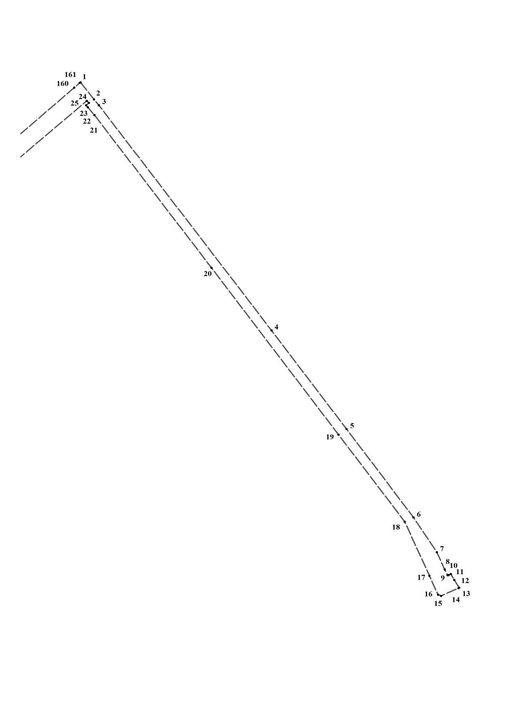

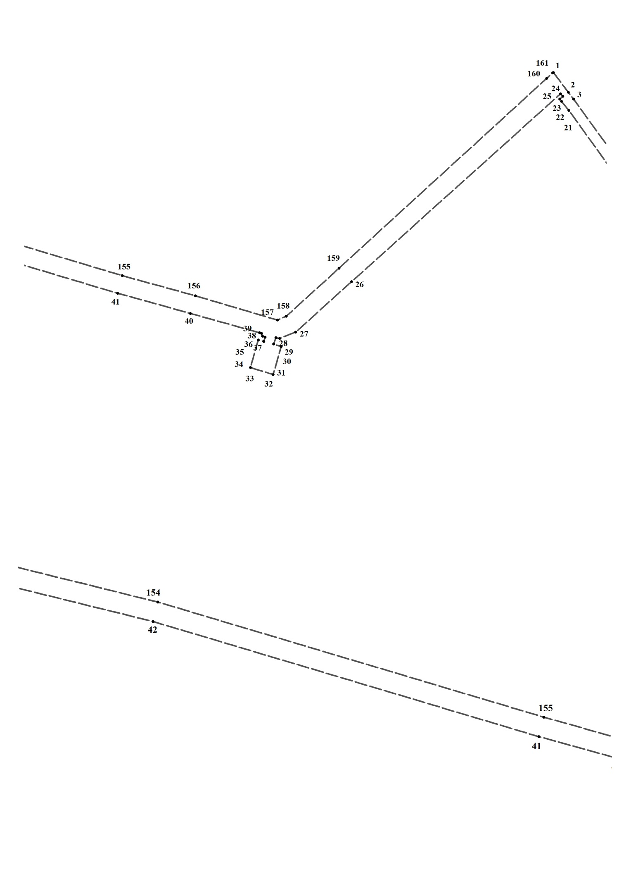

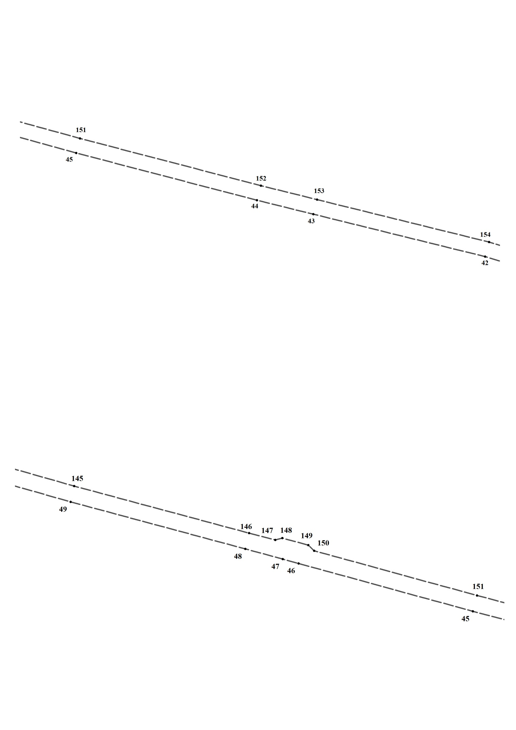

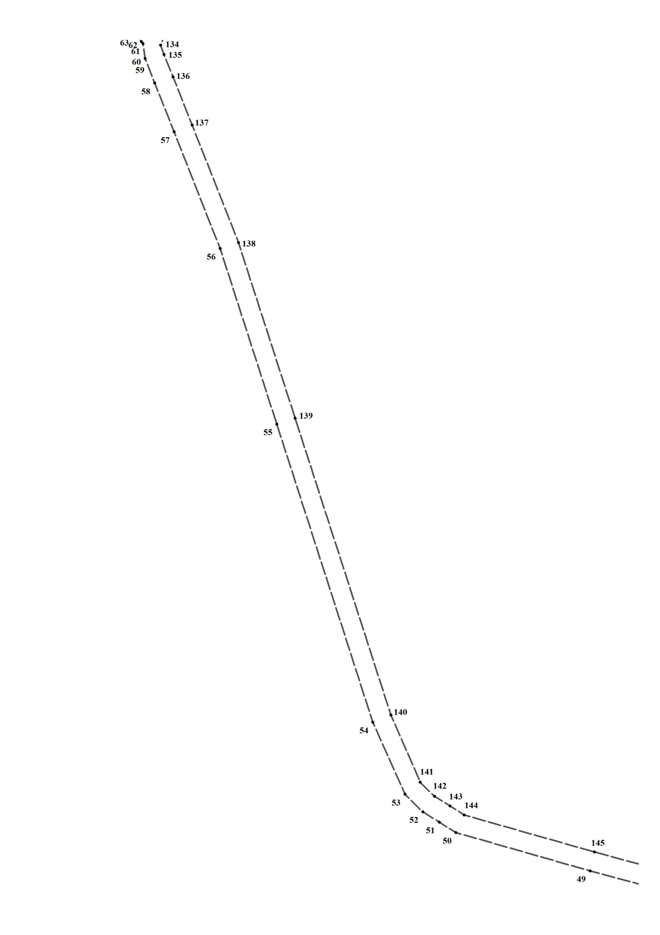

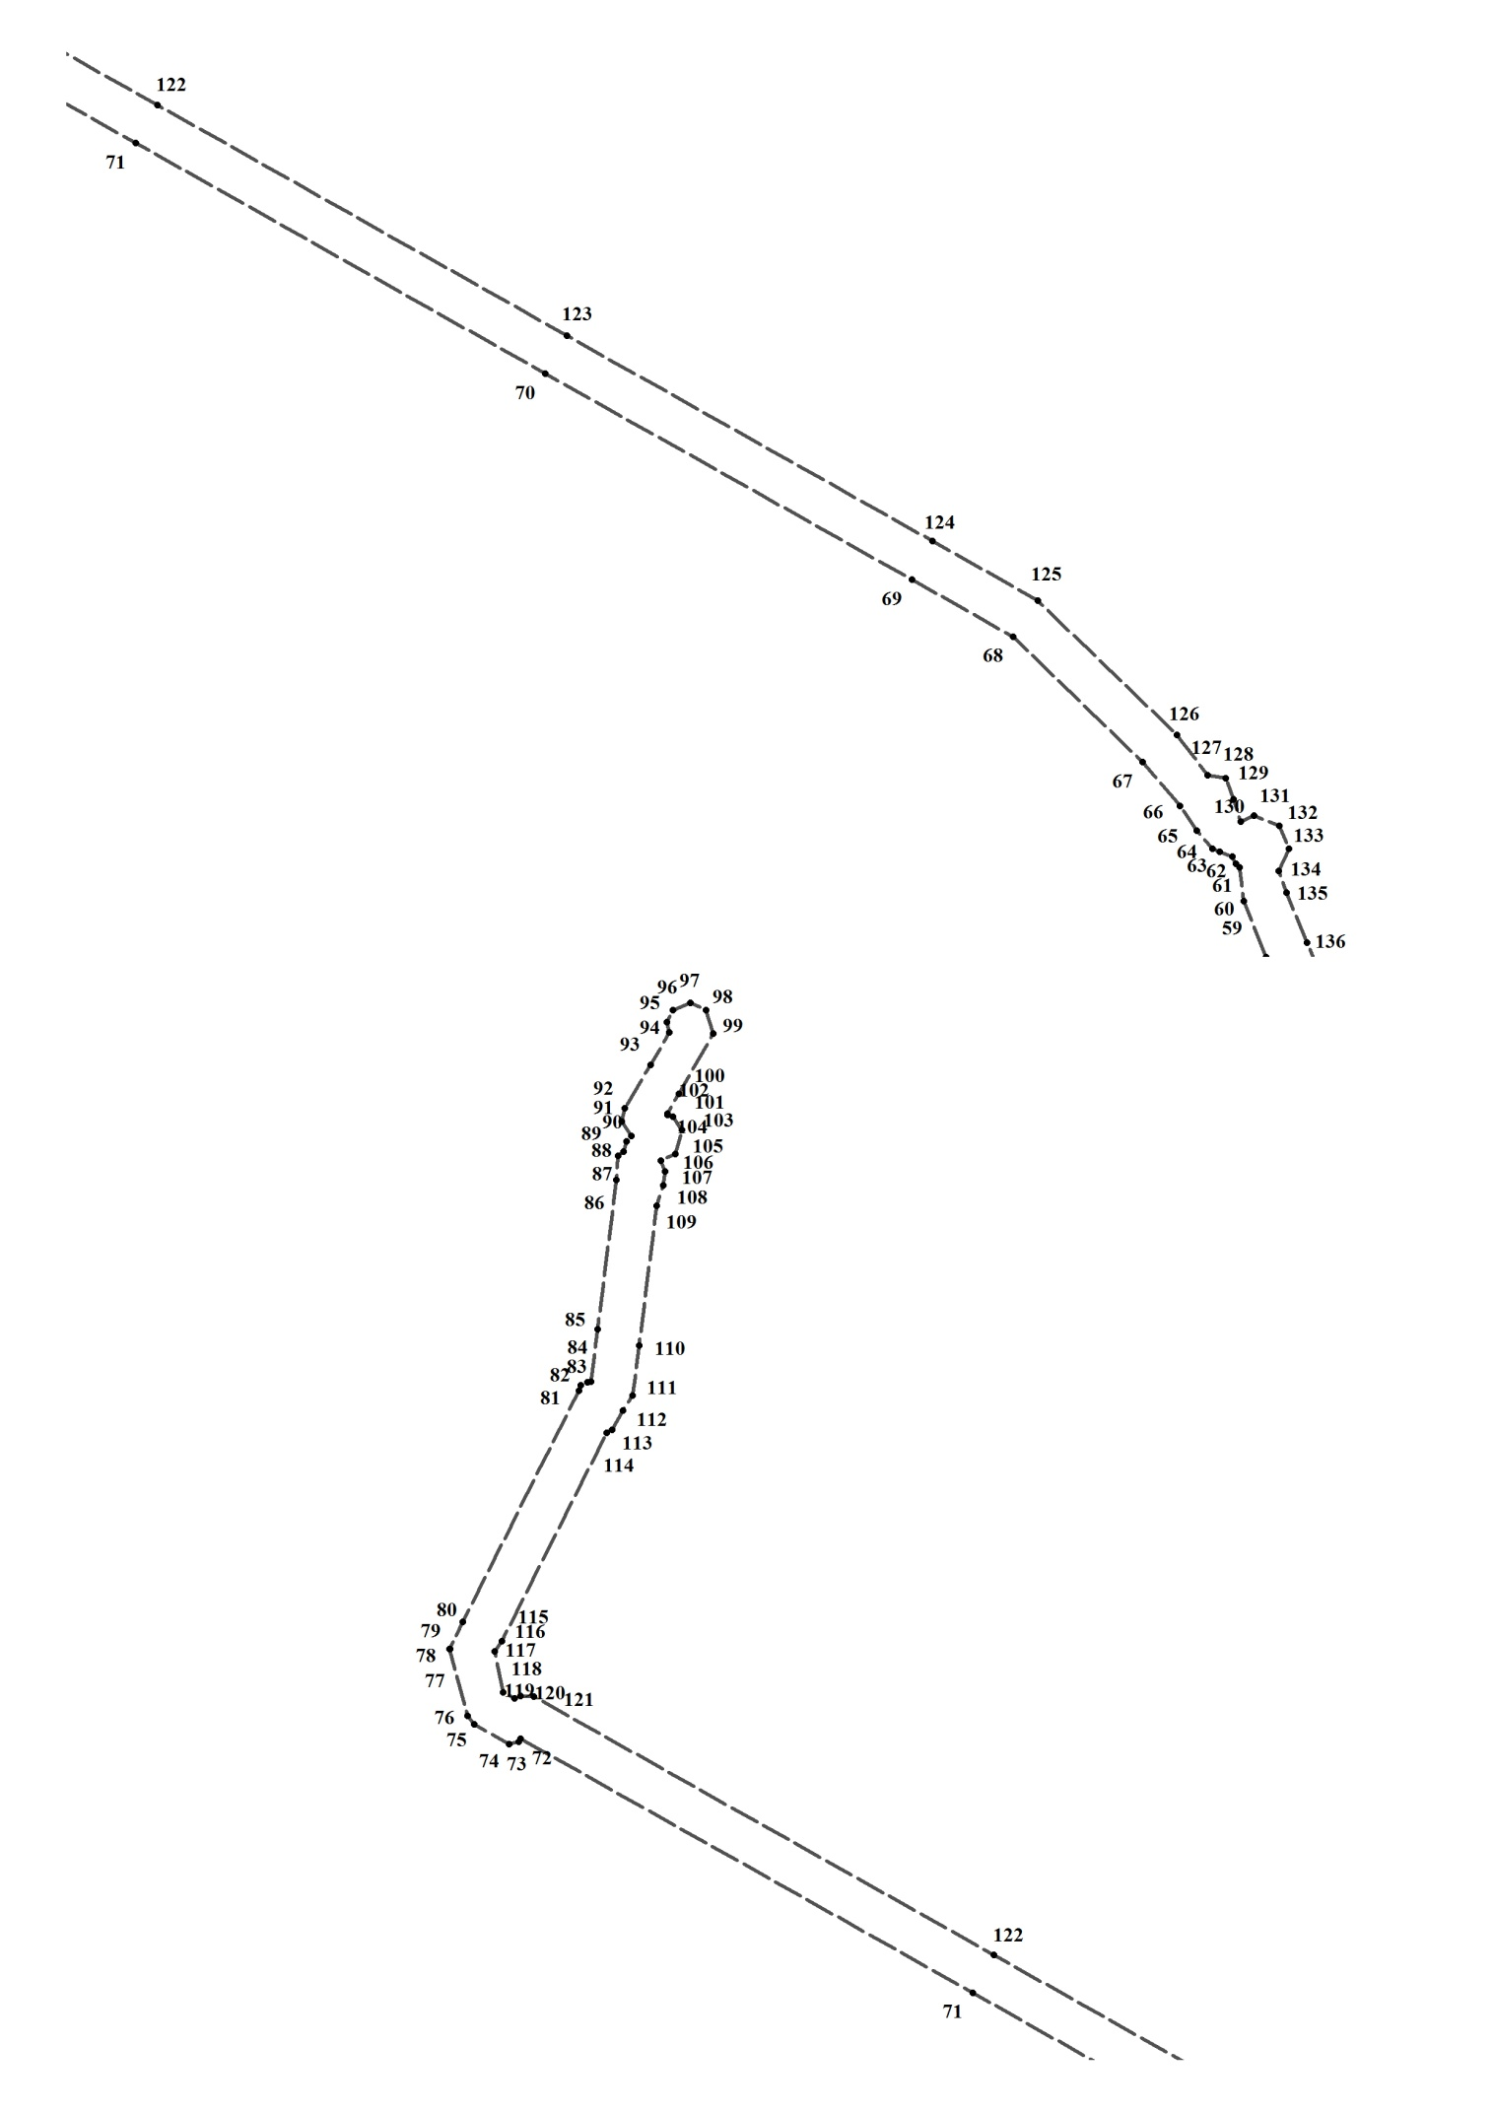

Таблица № 2

Каталог координат поворотных точек границ проекта межевания территории

(Система координат местная Новосибирской области)

|  |  |  |
| --- | --- | --- |
| Номер точки | Х | У |
| 1 | 437629.97 | 3341490.53 |
| 2 | 437586.71 | 3341522.60 |
| 3 | 437572.00 | 3341534.37 |
| 4 | 437000.81 | 3341947.31 |
| 5 | 436751.11 | 3342126.70 |
| 6 | 436527.11 | 3342286.81 |
| 7 | 436438.66 | 3342343.02 |
| 8 | 436394.90 | 3342361.91 |
| 9 | 436380.10 | 3342368.86 |
| 10 | 436380.42 | 3342370.76 |
| 11 | 436382.94 | 3342376.33 |
| 12 | 436368.23 | 3342384.74 |
| 13 | 436348.31 | 3342396.41 |
| 14 | 436347.48 | 3342394.58 |
| 15 | 436327.64 | 3342352.90 |
| 16 | 436330.78 | 3342346.01 |
| 17 | 436379.24 | 3342325.09 |
| 18 | 436515.90 | 3342266.22 |
| 19 | 436736.96 | 3342107.60 |
| 20 | 437160.19 | 3341803.74 |
| 21 | 437547.00 | 3341523.93 |
| 22 | 437567.24 | 3341508.08 |
| 23 | 437571.98 | 3341504.03 |
| 24 | 437577.95 | 3341510.57 |
| 25 | 437583.52 | 3341505.61 |
| 26 | 437174.04 | 3341049.61 |
| 27 | 437064.05 | 3340927.70 |
| 28 | 437050.29 | 3340893.00 |
| 29 | 437051.85 | 3340884.55 |
| 30 | 437038.18 | 3340879.96 |
| 31 | 437032.32 | 3340896.42 |
| 32 | 436971.04 | 3340878.89 |
| 33 | 436986.61 | 3340828.89 |
| 34 | 437046.76 | 3340846.30 |
| 35 | 437043.19 | 3340858.16 |
| 36 | 437052.74 | 3340860.89 |
| 37 | 437054.78 | 3340855.28 |
| 38 | 437061.10 | 3340853.13 |
| 39 | 437062.49 | 3340848.75 |
| 40 | 437104.59 | 3340698.08 |
| 41 | 437148.53 | 3340539.40 |
| 42 | 437380.22 | 3339762.24 |
| 43 | 437492.57 | 3339306.98 |
| 44 | 437529.41 | 3339158.24 |
| 45 | 437654.38 | 3338679.74 |
| 46 | 437771.64 | 3338253.78 |
| 47 | 437781.96 | 3338215.08 |
| 48 | 437806.83 | 3338123.56 |
| 49 | 437921.74 | 3337696.45 |
| 50 | 438001.04 | 3337418.56 |
| 51 | 438022.67 | 3337384.05 |
| 52 | 438044.24 | 3337349.86 |
| 53 | 438080.25 | 3337312.89 |
| 54 | 438229.39 | 3337246.43 |
| 55 | 438846.13 | 3337047.28 |
| 56 | 439209.69 | 3336929.91 |
| 57 | 439450.83 | 3336834.57 |
| 58 | 439551.57 | 3336794.32 |
| 59 | 439602.53 | 3336774.19 |
| 60 | 439633.66 | 3336770.09 |
| 61 | 439637.03 | 3336766.67 |
| 62 | 439643.30 | 3336763.70 |
| 63 | 439647.63 | 3336752.13 |
| 64 | 439650.76 | 3336745.16 |
| 65 | 439667.01 | 3336731.04 |
| 66 | 439689.64 | 3336715.74 |
| 67 | 439729.77 | 3336681.57 |
| 68 | 439844.39 | 3336563.32 |
| 69 | 439896.59 | 3336470.35 |
| 70 | 440084.87 | 3336135.46 |
| 71 | 440295.77 | 3335760.74 |
| 72 | 440529.45 | 3335345.16 |
| 73 | 440526.54 | 3335343.64 |
| 74 | 440524.09 | 3335334.53 |
| 75 | 440542.37 | 3335302.25 |
| 76 | 440550.29 | 3335296.29 |
| 77 | 440611.67 | 3335279.76 |
| 78 | 440611.64 | 3335280.35 |
| 79 | 440611.67 | 3335279.77 |
| 80 | 440636.90 | 3335291.93 |
| 81 | 440849.53 | 3335398.85 |
| 82 | 440854.46 | 3335400.51 |
| 83 | 440857.32 | 3335406.71 |
| 84 | 440857.51 | 3335409.81 |
| 85 | 440905.98 | 3335415.88 |
| 86 | 441043.12 | 3335432.94 |
| 87 | 441065.25 | 3335434.83 |
| 88 | 441068.94 | 3335439.77 |
| 89 | 441078.73 | 3335442.59 |
| 90 | 441083.54 | 3335446.80 |
| 91 | 441096.93 | 3335438.35 |
| 92 | 441108.88 | 3335440.96 |
| 93 | 441149.04 | 3335464.83 |
| 94 | 441178.57 | 3335482.11 |
| 95 | 441188.28 | 3335479.75 |
| 96 | 441199.16 | 3335485.38 |
| 97 | 441205.92 | 3335501.07 |
| 98 | 441199.21 | 3335515.80 |
| 99 | 441177.92 | 3335522.25 |
| 100 | 441122.21 | 3335490.72 |
| 101 | 441104.32 | 3335480.07 |
| 102 | 441103.11 | 3335479.99 |
| 103 | 441101.48 | 3335485.26 |
| 104 | 441089.28 | 3335493.41 |
| 105 | 441066.80 | 3335487.23 |
| 106 | 441060.63 | 3335474.30 |
| 107 | 441050.91 | 3335477.94 |
| 108 | 441038.32 | 3335476.53 |
| 109 | 441019.40 | 3335470.30 |
| 110 | 440890.80 | 3335454.27 |
| 111 | 440845.21 | 3335447.89 |
| 112 | 440830.96 | 3335439.40 |
| 113 | 440813.44 | 3335429.26 |
| 114 | 440810.74 | 3335424.13 |
| 115 | 440619.21 | 3335327.80 |
| 116 | 440609.39 | 3335321.20 |
| 117 | 440609.39 | 3335321.17 |
| 118 | 440571.83 | 3335329.31 |
| 119 | 440566.68 | 3335339.48 |
| 120 | 440568.61 | 3335345.37 |
| 121 | 440568.30 | 3335357.22 |
| 122 | 440330.50 | 3335780.58 |
| 123 | 440119.63 | 3336155.24 |
| 124 | 439931.84 | 3336489.25 |
| 125 | 439877.38 | 3336585.93 |
| 126 | 439754.90 | 3336712.69 |
| 127 | 439717.92 | 3336740.97 |
| 128 | 439715.26 | 3336757.34 |
| 129 | 439695.90 | 3336764.86 |
| 130 | 439675.31 | 3336771.39 |
| 131 | 439681.15 | 3336783.30 |
| 132 | 439671.43 | 3336806.40 |
| 133 | 439650.49 | 3336815.28 |
| 134 | 439630.04 | 3336806.18 |
| 135 | 439610.58 | 3336813.28 |
| 136 | 439564.73 | 3336832.09 |
| 137 | 439465.01 | 3336871.98 |
| 138 | 439221.62 | 3336968.09 |
| 139 | 438858.07 | 3337085.46 |
| 140 | 438243.97 | 3337283.62 |
| 141 | 438105.02 | 3337344.31 |
| 142 | 438075.98 | 3337374.20 |
| 143 | 438056.06 | 3337406.06 |
| 144 | 438037.44 | 3337435.13 |
| 145 | 437960.74 | 3337705.31 |
| 146 | 437845.70 | 3338132.71 |
| 147 | 437828.63 | 3338196.56 |
| 148 | 437833.32 | 3338214.04 |
| 149 | 437816.32 | 3338277.72 |
| 150 | 437802.56 | 3338292.02 |
| 151 | 437693.13 | 3338689.66 |
| 152 | 437568.13 | 3339168.25 |
| 153 | 437531.24 | 3339317.18 |
| 154 | 437418.94 | 3339772.30 |
| 155 | 437187.24 | 3340549.51 |
| 156 | 437142.96 | 3340709.33 |
| 157 | 437090.01 | 3340888.27 |
| 158 | 437098.60 | 3340907.55 |
| 159 | 437203.19 | 3341022.23 |
| 160 | 437617.02 | 3341475.29 |
| 161 | 437629.08 | 3341488.95 |

Схема № 2

Разбивочный план границ образуемого земельного участка № 1

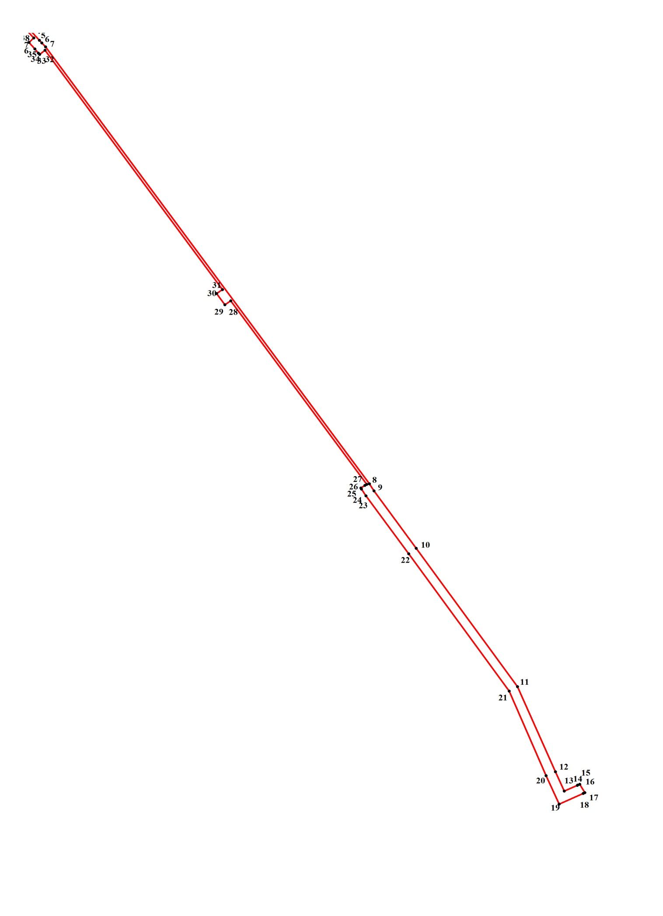

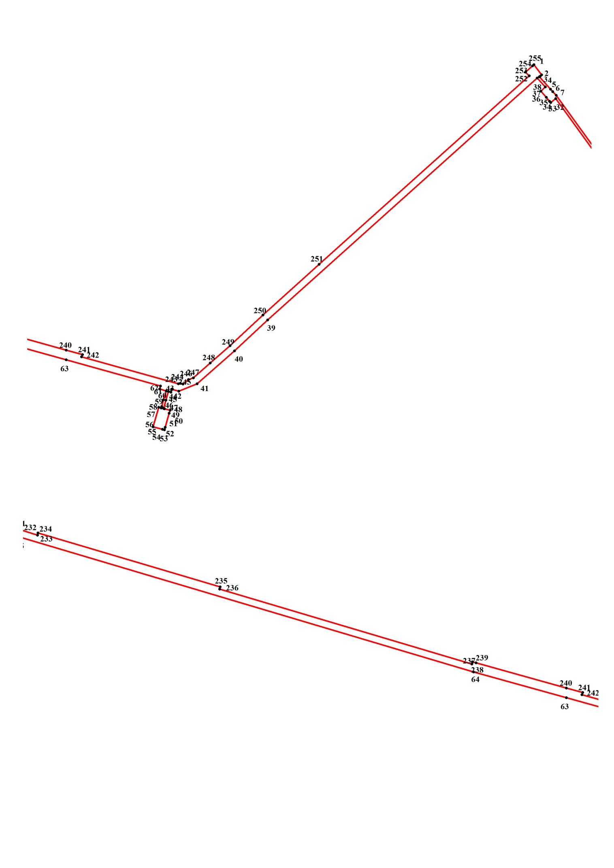

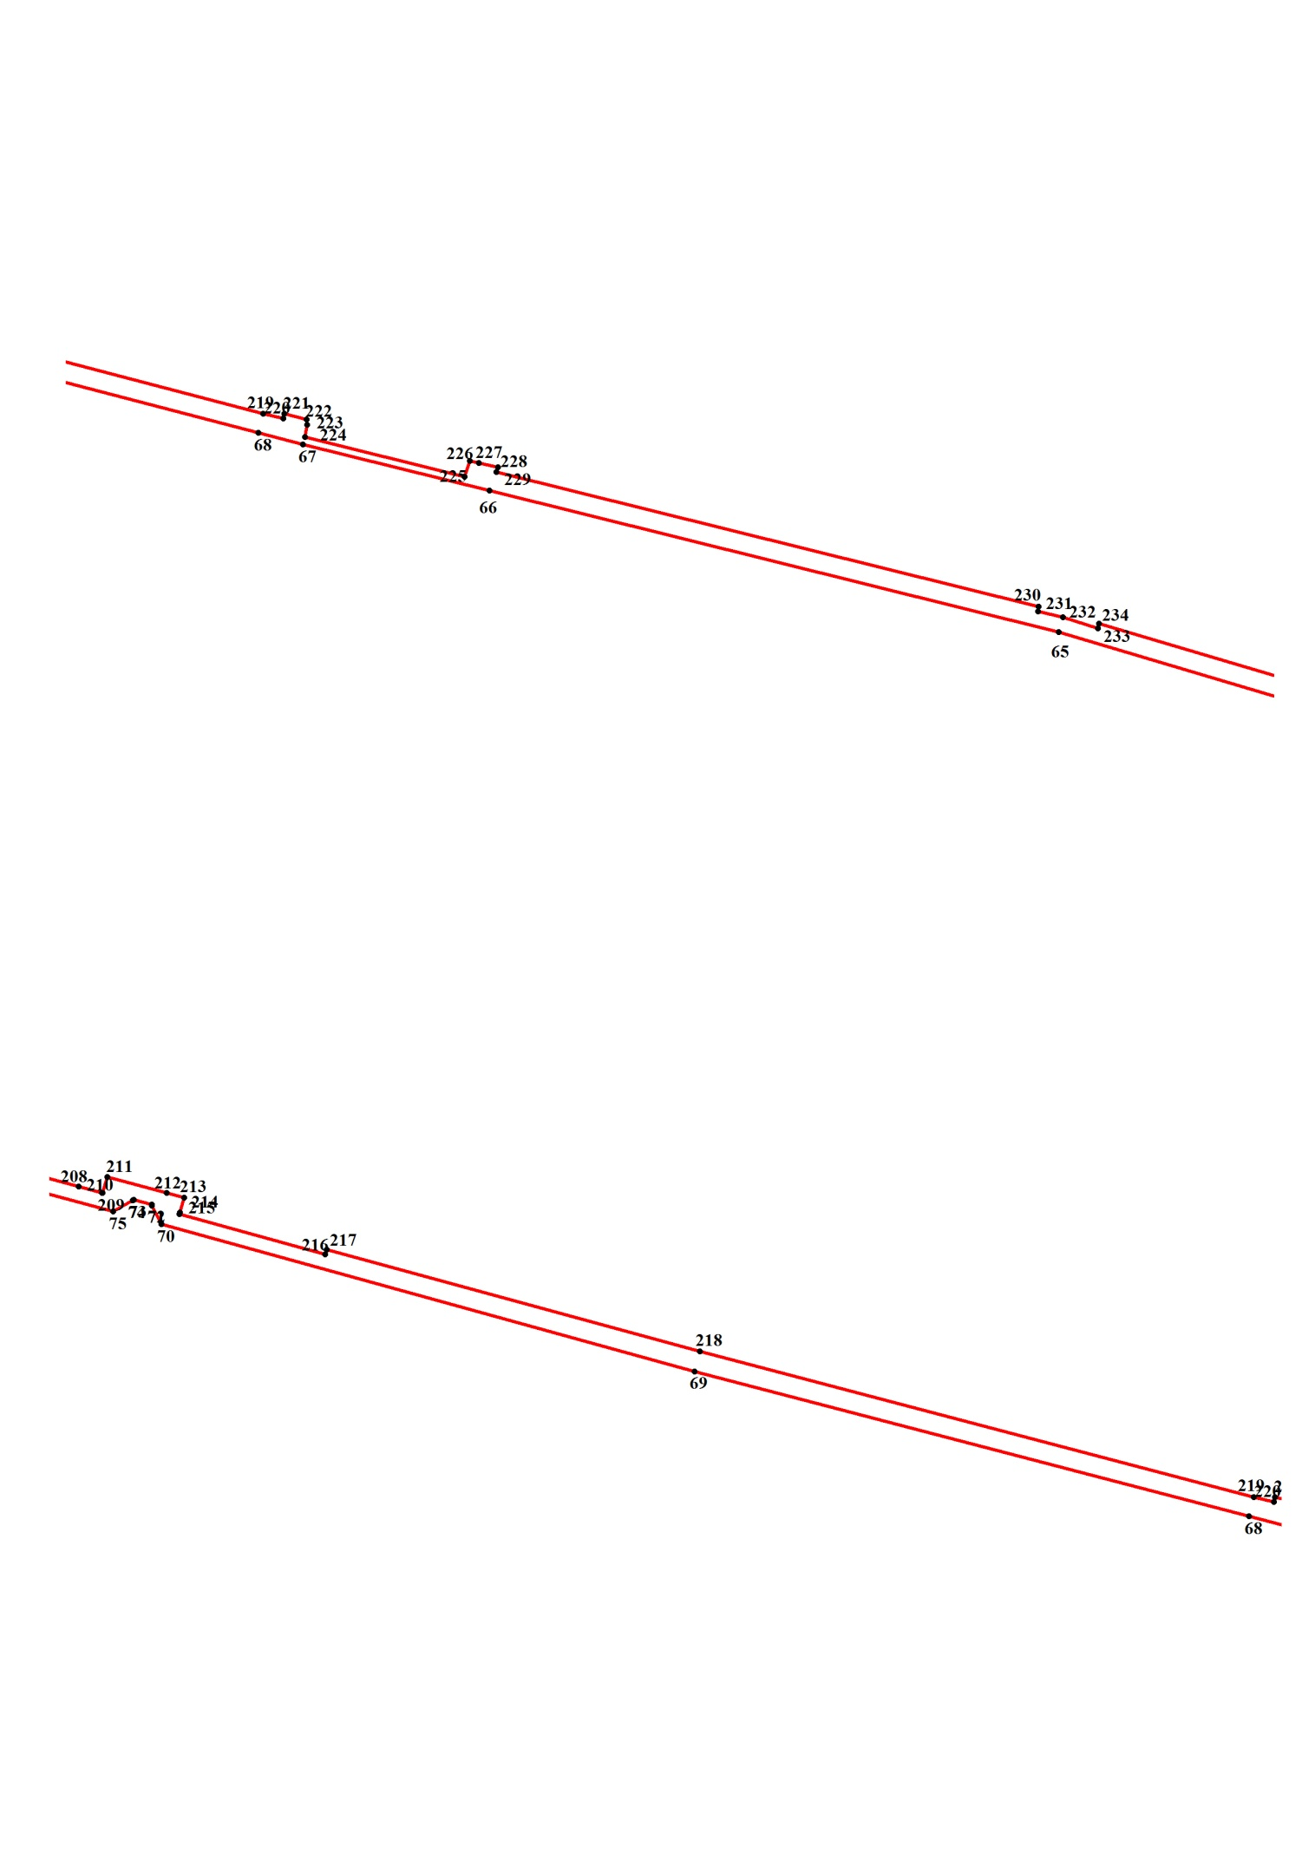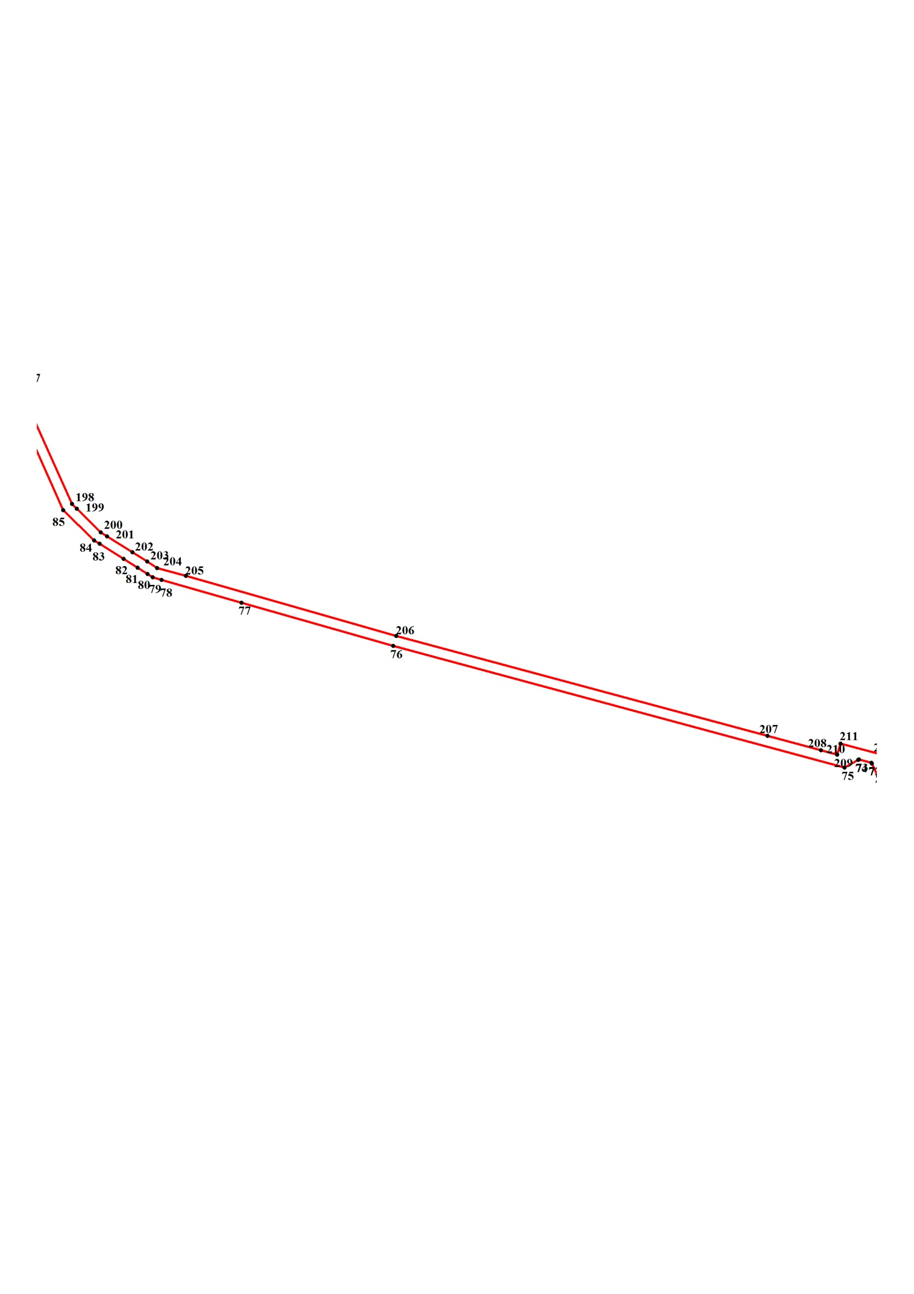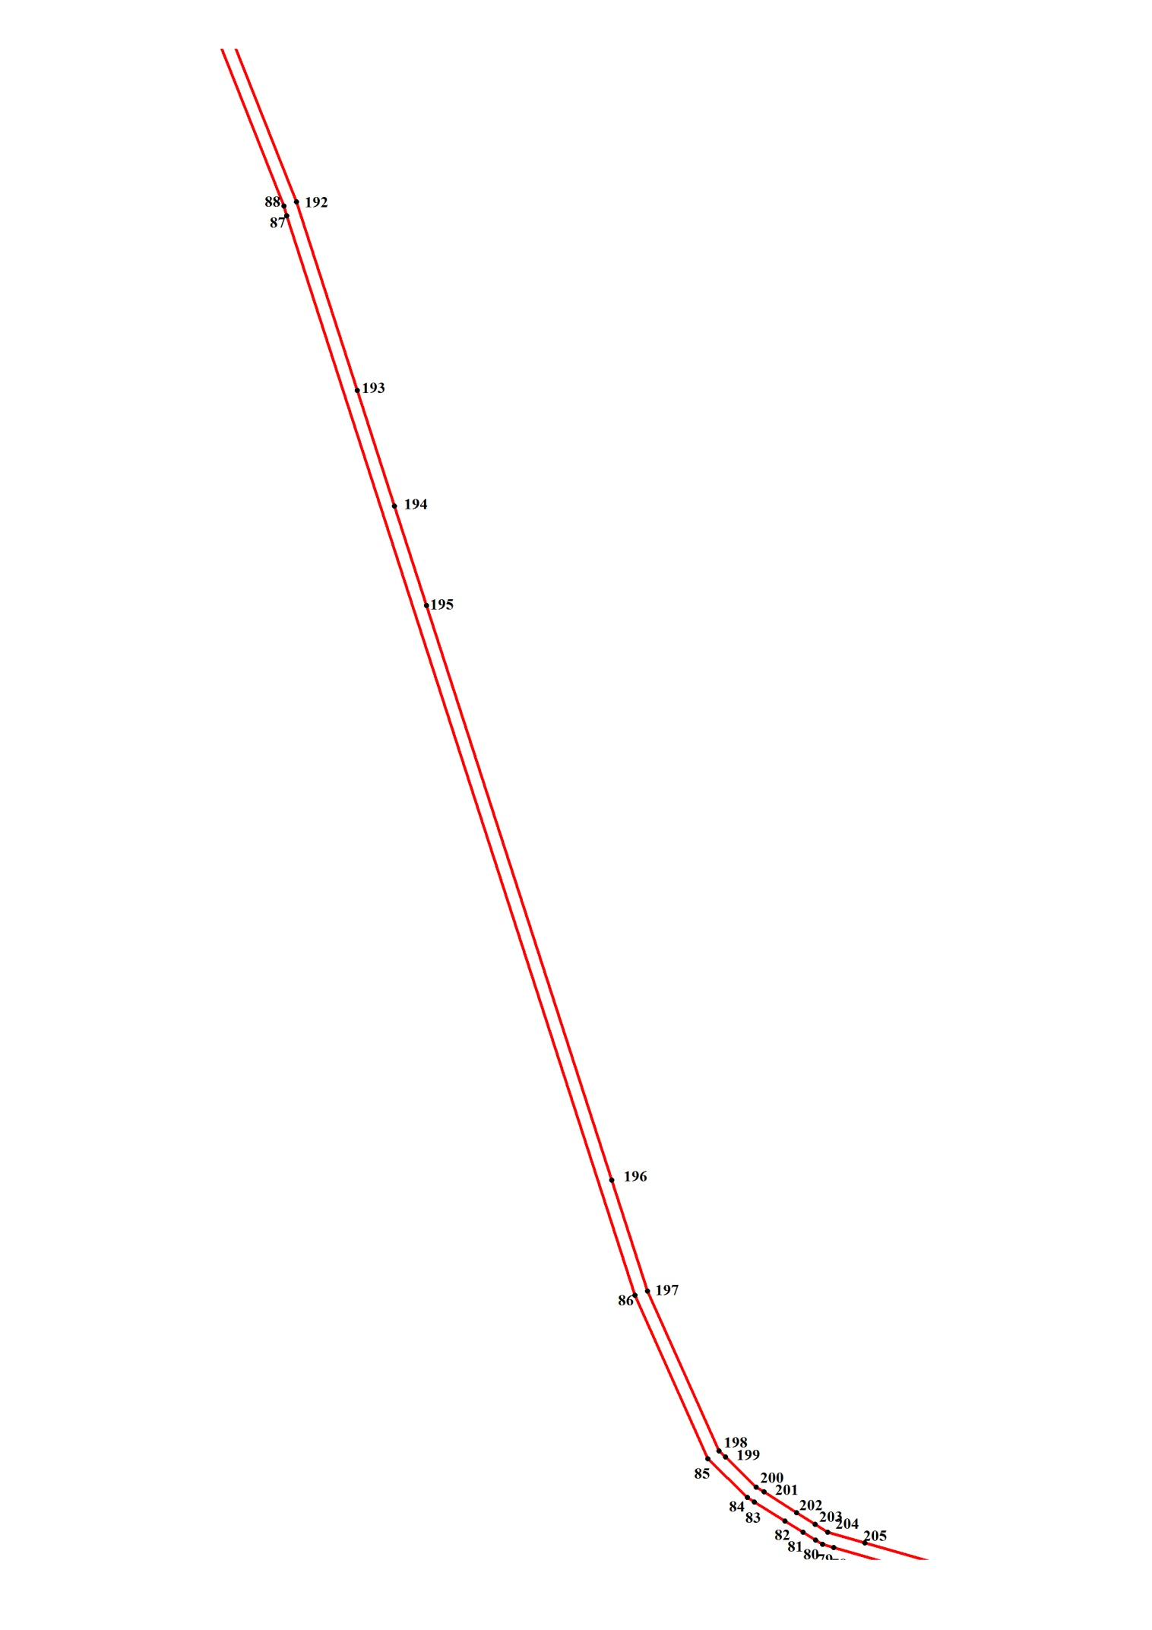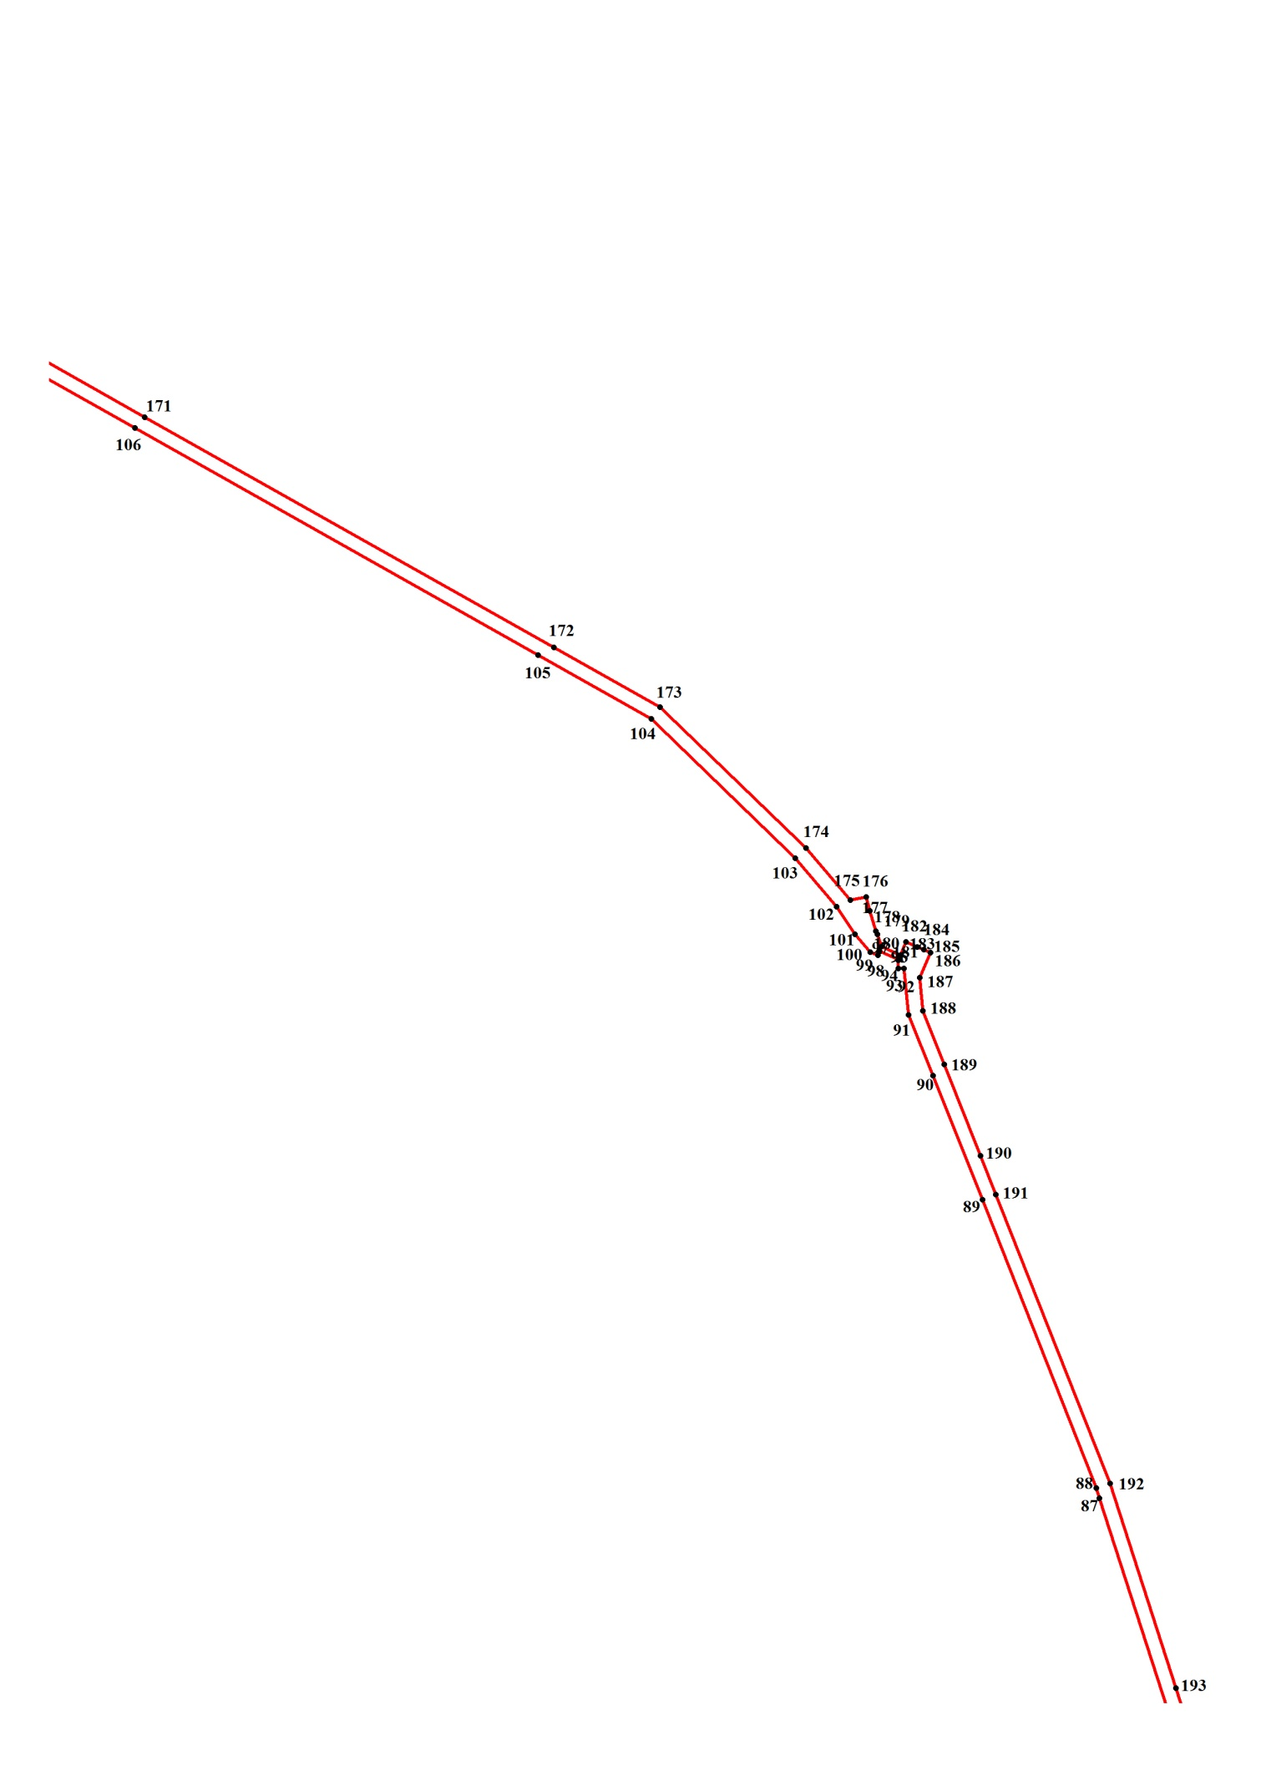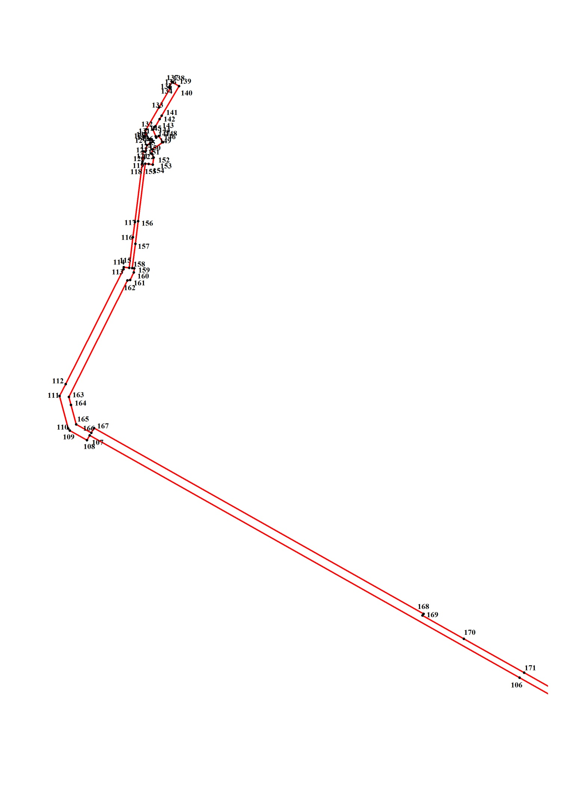

Таблица № 3

Каталог координат поворотных точек границ

образуемого земельного участка № 1

(Система координат местная Новосибирской области)

|  |  |  |
| --- | --- | --- |
| № точки | Х | У |
| 1 | 437616.62 | 3341500.42 |
| 2 | 437598.90 | 3341513.56 |
| 3 | 437596.70 | 3341511.09 |
| 4 | 437595.62 | 3341509.88 |
| 5 | 437574.60 | 3341528.90 |
| 6 | 437570.47 | 3341532.66 |
| 7 | 437563.87 | 3341538.66 |
| 8 | 436855.34 | 3342051.52 |
| 9 | 436844.00 | 3342058.73 |
| 10 | 436750.52 | 3342125.89 |
| 11 | 436526.31 | 3342286.13 |
| 12 | 436388.37 | 3342346.22 |
| 13 | 436357.16 | 3342360.34 |
| 14 | 436366.40 | 3342380.88 |
| 15 | 436366.70 | 3342381.43 |
| 16 | 436368.20 | 3342384.76 |
| 17 | 436354.27 | 3342392.91 |
| 18 | 436353.10 | 3342390.32 |
| 19 | 436335.99 | 3342352.36 |
| 20 | 436381.92 | 3342331.57 |
| 21 | 436519.13 | 3342272.84 |
| 22 | 436741.79 | 3342113.70 |
| 23 | 436835.59 | 3342046.30 |
| 24 | 436846.91 | 3342039.11 |
| 25 | 436848.50 | 3342037.93 |
| 26 | 436852.65 | 3342044.44 |
| 27 | 436854.44 | 3342047.24 |
| 28 | 437152.03 | 3341831.72 |
| 29 | 437145.84 | 3341822.73 |
| 30 | 437164.08 | 3341809.55 |
| 31 | 437170.28 | 3341818.62 |
| 32 | 437558.24 | 3341537.79 |
| 33 | 437551.66 | 3341529.18 |
| 34 | 437553.90 | 3341527.20 |
| 35 | 437560.43 | 3341521.44 |
| 36 | 437570.93 | 3341512.19 |
| 37 | 437578.35 | 3341520.05 |
| 38 | 437593.48 | 3341505.95 |
| 39 | 437179.25 | 3341044.90 |
| 40 | 437126.54 | 3340988.06 |
| 41 | 437070.03 | 3340923.99 |
| 42 | 437057.53 | 3340892.68 |
| 43 | 437060.79 | 3340880.64 |
| 44 | 437055.90 | 3340879.20 |
| 45 | 437056.98 | 3340874.86 |
| 46 | 437042.25 | 3340870.75 |
| 47 | 437028.29 | 3340866.85 |
| 48 | 437027.64 | 3340866.67 |
| 49 | 437027.33 | 3340867.94 |
| 50 | 437024.92 | 3340877.75 |
| 51 | 437019.94 | 3340876.30 |
| 52 | 436995.58 | 3340869.35 |
| 53 | 436991.23 | 3340868.12 |
| 54 | 436992.15 | 3340864.87 |
| 55 | 436996.67 | 3340848.85 |
| 56 | 437029.81 | 3340858.48 |
| 57 | 437028.73 | 3340862.82 |
| 58 | 437031.23 | 3340863.51 |
| 59 | 437042.45 | 3340866.65 |
| 60 | 437058.07 | 3340871.01 |
| 61 | 437061.33 | 3340859.93 |
| 62 | 437066.22 | 3340861.37 |
| 63 | 437111.32 | 3340700.00 |
| 64 | 437155.34 | 3340541.04 |
| 65 | 437386.28 | 3339763.58 |
| 66 | 437499.30 | 3339308.86 |
| 67 | 437536.25 | 3339160.01 |
| 68 | 437545.49 | 3339124.37 |
| 69 | 437661.23 | 3338681.20 |
| 70 | 437778.61 | 3338255.38 |
| 71 | 437793.78 | 3338247.96 |
| 72 | 437794.36 | 3338247.67 |
| 73 | 437798.17 | 3338233.22 |
| 74 | 437797.67 | 3338232.34 |
| 75 | 437788.93 | 3338216.85 |
| 76 | 437928.58 | 3337698.06 |
| 77 | 437978.34 | 3337523.44 |
| 78 | 438004.50 | 3337431.64 |
| 79 | 438007.37 | 3337421.56 |
| 80 | 438011.20 | 3337415.47 |
| 81 | 438018.30 | 3337404.17 |
| 82 | 438028.48 | 3337387.98 |
| 83 | 438045.79 | 3337360.43 |
| 84 | 438049.76 | 3337354.12 |
| 85 | 438084.53 | 3337318.48 |
| 86 | 438231.79 | 3337252.97 |
| 87 | 439203.34 | 3336939.31 |
| 88 | 439212.07 | 3336936.49 |
| 89 | 439451.16 | 3336842.08 |
| 90 | 439553.93 | 3336801.05 |
| 91 | 439604.39 | 3336780.90 |
| 92 | 439642.81 | 3336777.06 |
| 93 | 439642.97 | 3336777.05 |
| 94 | 439642.97 | 3336772.23 |
| 95 | 439649.49 | 3336772.23 |
| 96 | 439650.04 | 3336772.71 |
| 97 | 439657.10 | 3336756.82 |
| 98 | 439656.56 | 3336756.33 |
| 99 | 439653.84 | 3336755.37 |
| 100 | 439656.56 | 3336749.11 |
| 101 | 439671.23 | 3336736.58 |
| 102 | 439694.05 | 3336721.17 |
| 103 | 439734.26 | 3336686.97 |
| 104 | 439850.01 | 3336567.51 |
| 105 | 439902.87 | 3336473.47 |
| 106 | 440091.02 | 3336138.98 |
| 107 | 440539.02 | 3335342.55 |
| 108 | 440530.33 | 3335337.73 |
| 109 | 440548.26 | 3335305.90 |
| 110 | 440552.11 | 3335303.04 |
| 111 | 440611.84 | 3335286.67 |
| 112 | 440634.12 | 3335298.23 |
| 113 | 440846.58 | 3335405.17 |
| 114 | 440850.38 | 3335405.65 |
| 115 | 440849.30 | 3335415.77 |
| 116 | 440905.75 | 3335422.85 |
| 117 | 440933.75 | 3335426.34 |
| 118 | 441042.66 | 3335439.92 |
| 119 | 441046.00 | 3335440.33 |
| 120 | 441064.48 | 3335441.78 |
| 121 | 441063.99 | 3335445.24 |
| 122 | 441063.94 | 3335445.63 |
| 123 | 441075.89 | 3335449.00 |
| 124 | 441080.24 | 3335454.78 |
| 125 | 441079.69 | 3335455.27 |
| 126 | 441082.41 | 3335459.12 |
| 127 | 441086.69 | 3335456.28 |
| 128 | 441086.76 | 3335456.23 |
| 129 | 441085.67 | 3335453.82 |
| 130 | 441087.46 | 3335452.63 |
| 131 | 441098.71 | 3335445.15 |
| 132 | 441105.78 | 3335447.56 |
| 133 | 441145.67 | 3335470.96 |
| 134 | 441181.31 | 3335491.87 |
| 135 | 441182.19 | 3335490.58 |
| 136 | 441182.94 | 3335489.47 |
| 137 | 441193.26 | 3335495.25 |
| 138 | 441192.32 | 3335496.50 |
| 139 | 441192.18 | 3335496.69 |
| 140 | 441185.11 | 3335508.25 |
| 141 | 441130.77 | 3335475.98 |
| 142 | 441124.25 | 3335472.13 |
| 143 | 441111.21 | 3335464.42 |
| 144 | 441109.58 | 3335462.01 |
| 145 | 441104.69 | 3335460.08 |
| 146 | 441092.32 | 3335464.96 |
| 147 | 441090.02 | 3335465.86 |
| 148 | 441092.74 | 3335470.68 |
| 149 | 441081.33 | 3335478.39 |
| 150 | 441068.28 | 3335459.12 |
| 151 | 441060.68 | 3335457.19 |
| 152 | 441053.07 | 3335461.05 |
| 153 | 441040.03 | 3335459.60 |
| 154 | 441041.11 | 3335451.89 |
| 155 | 441041.66 | 3335445.63 |
| 156 | 440935.45 | 3335432.37 |
| 157 | 440893.39 | 3335427.12 |
| 158 | 440848.75 | 3335421.55 |
| 159 | 440848.21 | 3335425.40 |
| 160 | 440840.60 | 3335424.44 |
| 161 | 440826.48 | 3335417.69 |
| 162 | 440825.93 | 3335412.39 |
| 163 | 440610.21 | 3335304.01 |
| 164 | 440595.54 | 3335307.87 |
| 165 | 440559.67 | 3335317.50 |
| 166 | 440543.91 | 3335345.44 |
| 167 | 440552.61 | 3335350.74 |
| 168 | 440209.19 | 3335961.05 |
| 169 | 440205.92 | 3335959.12 |
| 170 | 440163.00 | 3336035.71 |
| 171 | 440100.22 | 3336147.31 |
| 172 | 439909.32 | 3336486.61 |
| 173 | 439859.79 | 3336574.73 |
| 174 | 439742.96 | 3336695.64 |
| 175 | 439699.49 | 3336732.73 |
| 176 | 439702.20 | 3336745.74 |
| 177 | 439690.79 | 3336748.63 |
| 178 | 439673.95 | 3336753.93 |
| 179 | 439671.23 | 3336754.89 |
| 180 | 439660.91 | 3336758.26 |
| 181 | 439653.84 | 3336774.16 |
| 182 | 439664.71 | 3336778.97 |
| 183 | 439660.83 | 3336788.00 |
| 184 | 439660.72 | 3336788.25 |
| 185 | 439658.40 | 3336793.66 |
| 186 | 439656.02 | 3336799.21 |
| 187 | 439635.37 | 3336790.05 |
| 188 | 439607.65 | 3336792.94 |
| 189 | 439563.09 | 3336810.64 |
| 190 | 439487.56 | 3336840.63 |
| 191 | 439455.50 | 3336853.16 |
| 192 | 439215.87 | 3336948.05 |
| 193 | 439046.04 | 3337002.71 |
| 194 | 438942.00 | 3337036.20 |
| 195 | 438852.56 | 3337065.05 |
| 196 | 438335.39 | 3337231.83 |
| 197 | 438235.60 | 3337264.05 |
| 198 | 438091.60 | 3337328.59 |
| 199 | 438086.16 | 3337334.37 |
| 200 | 438058.99 | 3337361.83 |
| 201 | 438054.65 | 3337369.06 |
| 202 | 438036.05 | 3337398.33 |
| 203 | 438025.47 | 3337414.99 |
| 204 | 438018.24 | 3337426.38 |
| 205 | 438009.00 | 3337459.61 |
| 206 | 437939.99 | 3337701.43 |
| 207 | 437825.34 | 3338128.21 |
| 208 | 437808.69 | 3338189.47 |
| 209 | 437803.60 | 3338208.17 |
| 210 | 437803.85 | 3338208.25 |
| 211 | 437816.64 | 3338212.03 |
| 212 | 437803.60 | 3338259.72 |
| 213 | 437799.80 | 3338273.69 |
| 214 | 437788.24 | 3338270.27 |
| 215 | 437786.76 | 3338269.83 |
| 216 | 437754.70 | 3338386.40 |
| 217 | 437758.50 | 3338387.37 |
| 218 | 437676.99 | 3338685.54 |
| 219 | 437560.71 | 3339128.22 |
| 220 | 437556.90 | 3339144.12 |
| 221 | 437560.71 | 3339145.08 |
| 222 | 437556.36 | 3339162.90 |
| 223 | 437552.01 | 3339163.38 |
| 224 | 437542.23 | 3339161.46 |
| 225 | 437510.71 | 3339289.11 |
| 226 | 437523.21 | 3339293.44 |
| 227 | 437521.62 | 3339300.44 |
| 228 | 437518.25 | 3339315.58 |
| 229 | 437514.52 | 3339314.64 |
| 230 | 437406.93 | 3339747.68 |
| 231 | 437403.12 | 3339747.20 |
| 232 | 437398.23 | 3339766.95 |
| 233 | 437389.54 | 3339794.89 |
| 234 | 437393.34 | 3339795.85 |
| 235 | 437300.97 | 3340107.51 |
| 236 | 437297.16 | 3340106.55 |
| 237 | 437168.92 | 3340538.15 |
| 238 | 437172.73 | 3340539.11 |
| 239 | 437171.10 | 3340545.38 |
| 240 | 437127.62 | 3340700.00 |
| 241 | 437120.02 | 3340727.94 |
| 242 | 437116.21 | 3340726.50 |
| 243 | 437070.03 | 3340891.72 |
| 244 | 437071.12 | 3340895.11 |
| 245 | 437069.72 | 3340899.86 |
| 246 | 437077.28 | 3340909.10 |
| 247 | 437080.35 | 3340917.73 |
| 248 | 437105.89 | 3340946.63 |
| 249 | 437135.23 | 3340980.35 |
| 250 | 437187.94 | 3341036.71 |
| 251 | 437274.52 | 3341133.00 |
| 252 | 437597.16 | 3341492.19 |
| 253 | 437603.88 | 3341486.07 |
| 254 | 437614.27 | 3341497.94 |
| 255 | 437616.62 | 3341500.42 |